CARE Network dsesignated provider ongoing education
Presented by the Kempe Center
ECHO Session #10: Thoracic and Abdominal Injuries
Session Location: https://ucdenver.zoom.us/j/94223234963
Tuesday, June 15, 2021 (7:00 AM- 8:00 AM MT)
Overview, Target Audience and Learner Outcome
This ongoing education combines clinical presentations, as well as reviews of available evidence for current practice strategies related to physical abuse, sexual abuse and behavioral health. The monthly education is intended for new providers who attended the new provider training. Upon completion, the provider will report increased confidence incorporating new information related to medical evaluation and assessment for behavioral health needs with suspected abuse or neglect in children.
Objectives
Identify abusive abdominal injuries
Determine which abdominal injuries are abusive
Disclosures:
- Planning Committee: No financial disclosures to report for the planning committee
- Faculty: No financial disclosures to report for faculty presenter and panelists

Agenda Day 1

6:45 a.m. Pre-session/Game plan huddle
Connect with your ECHO coordinator

7:00 a.m. Start session
Welcome

7:03 a.m. Thoracic and Abdominal Injuries
Antonia Chiesa, MD
Associate Professor of Pediatrics, University of Colorado School of Medicine, Kempe Child Protection Team, Children’s Hospital Colorado

7:23 a.m. Q&A for presenter

7:33 p.m. Case Presentation/Discussion
Panel of Experts:
-Matt Dodson, LCSW, Director, Archuleta County Human Services
-Randy Fons, J.D., Deputy Executive Director, Rocky Mountain Children’s Law Center
-Angela Ramos, Parent Partner, Denver Parent Advocates Lending Support (DPALS)
-Lou Felipe, Assistant Professor, Deputy Director, START Clinic, CU School of Medicine, Department of Psychiatry

8:00 a.m. Closing Remarks & Adjourn
Evaluation reminder,
March session reminder

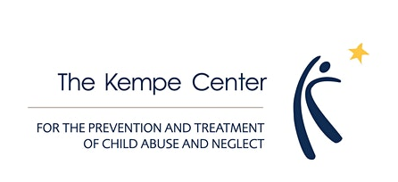

Continuing Education Credit
Continuing Medical Education: Children's Hospital Colorado is accredited by the Accreditation Council for Continuing Medical Education to provide continuing medical education for physicians.
Children's Hospital Colorado designates this Other activity (Internet Live Course) for a maximum of 1 AMA PRA Category 1 Credit(s)™. Physicians should only claim credit commensurate with the extent of their participation in the activity.
Nursing Continuing Professional Development: Children’s Hospital Colorado is approved as provider of nursing continuing professional development by the Colorado Nurses Association, an accredited approver by the American Nurses Credentialing Center’s Commission on Accreditation.
This educational activity for 1.0 nursing contact hour is provided by Children’s Hospital Colorado. Attendance and completion of the evaluation are required to obtain NCPD contact hours.
Further Information: contact Sarah Hunt, sarah.e.hunt@cuanschutz.edu or 720-864-5106

