The Rosenberry conference
Advancing Effective School Mental Health in Colorado
May 5, 2023
Children’s Hospital Colorado
Anschutz Medical Campus

Provided by
Children’s Hospital Colorado, Pediatric Mental Health Institute

The Rosenberry Conference

Course Overview and Target Audience
Mental health promotion efforts for children include creating supportive school, home, and community environments. For this to be optimized, a myriad of universal mental health promotion strategies (Tier 1), targeted mental health prevention and early intervention services (Tier 2), and individualized mental health treatment (Tier 3) must be systematically implemented. This course will review best practice guidelines for mental health and educational systems integration while reviewing model Tier 1, Tier 2, and Tier 3 mental health programs in schools. This course will offer the opportunity to increase competence, understanding, and skills related to school-based mental health endeavors through a public health framework. This conference will be of interest to Physicians, Psychologists, Advanced Practice Providers, Social Workers, Counselors, Family Navigators, School Behavioral Health Providers, Nurses, and School Administrators.

Learning Objectives
At the conclusion of the conference, participants will be to:
- Identify key strategies for mental health-education systems integration and advantages for both systems.
- Describe examples of model mental health promotion and prevention, targeted early intervention, and treatment programs in schools.
- Identify how chronic health conditions impact academic functioning, school performance, and behavioral and socioemotional health.
- Identify opportunities to improve interprofessional collaboration and overcome barriers that may influence collaboration practices.

Agenda

Friday, May 5, 2023

8:00 a.m. Welcome
Cindy Buchanan, PhD
Ron-Li Liaw, MD

8:15 Session One – The Critical Importance of School Mental Health in 2023
Mark D. Weist, PhD

10:00 Break

10:15 Session Two – Mental Health Promotion/Prevention (Tier 1) and Early Intervention (Tier 2) Programming in Schools: How do we advance the quality of services and supports?
Brian P. Daly, PhD

11:00 Break

11:15 Session Three – Strategies and Partnerships for Supporting Youth with Chronic Illnesses in Schools
Brian P. Daly, PhD

12:00 p.m. Lunch

12:45 Session Four - A Multidisciplinary Hospital-Based School and Treatment Program for Children with Significant Medical and Psychosocial Needs
Jennifer Lindwall, PhD Kay Troxell, BSN RN CPN

1:45 Break

2:00 Session Five – Improving Interprofessional Collaboration Across Clinical and School Contexts for Children with Neurodevelopmental Disorders
Bryn Harris, PhD, NSCP

3:30-3:45 Closing Comments, Evaluation Adjourn

Guest Faculty

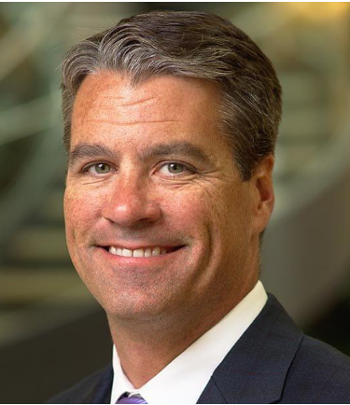

Brian P. Daly, PhD
Department Head, Professor, Department of Psychology
Drexel University
Philadelphia, PA

Brian Daly, PhD (he/him) is a clinical child and adolescent psychologist specializing in the assessment and treatment of children with a chronic illness, evaluation of adolescent health risk behaviors, development and evaluation of evidence-based psychosocial evaluations for youth, prevention and resiliency in urban youth and delivery of mental health promotion in schools. Following the completion of his doctorate in counseling psychology from Loyola University in Chicago, he completed a clinical internship in child psychology at the VA Maryland Health Care System/University of Maryland School of Medicine Psychology Internship Consortium. Subsequently, he completed a postdoctoral fellowship in pediatric psychology at Temple University Health Sciences Center. Following the fellowship, Dr. Daly was an assistant professor in the Department of Public Health at Temple University as well as the director of training for the APA-approved pre-doctoral clinical psychology internship program. He has co-authored two books, and more than 40 articles and book chapters. He is on the editorial board of Professional Psychology: Research and Practice, and a reviewer for more than 20 scientific journals. Currently, Dr. Daly is the chair of the Department of Psychology at Drexel University in Philadelphia, PA.

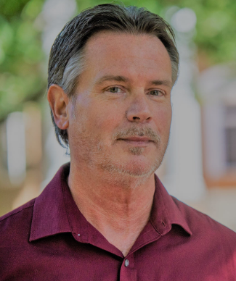

Mark D. Weist, PhD
Professor, Clinical-Community (CC) and School Psychology
Director, CC Psychology Doctoral Program
Lead, School Behavioral Health Team
University of South Carolina
Mark D. Weist (he/him) received a Ph.D. in clinical psychology from Virginia Tech in 1991 after completing his internship at Duke University, and he is a Professor in the Department of Psychology at the University of South Carolina (USC). In 1995, with colleagues from the University of Maryland, he established the National Center for School Mental Health, now in its 26th year of supporting this field (see www.schoolmentalhealth.org). He is also a partner on the National Center on Positive Behavioral Interventions and Supports (see www.pbis.org). He has edited or developed 15 books and has published and presented widely in areas of mental health-education system partnerships, school behavioral health (SBH), trauma, violence and youth, evidence-based practice, cognitive behavioral therapy, supporting military families, and advancing policies that support children and youth at local, state, regional, national, and international levels of scale. With colleagues, he currently leads the Southeastern School Behavioral Health Community (see www.schoolbehavioralhealth.org) and is leading or co-leading a number of federally funded studies on strategies to improve SBH effectiveness, impact and scaling up. Mark recently received the Faculty Achievement Award from the Southeastern Conference (campus winner from the USC).

Local Faculty

Bryn Harris, PhD
Professor, School of Education and Human Development
University of Colorado Denver
Bryn Harris, PhD (she/her) is a Professor in the School Psychology doctoral program in the School of Education and Human Development at the University of Colorado Denver. She has a secondary appointment in the Department of Pediatrics (Developmental Pediatrics) at the University of Colorado Denver Anschutz Medical Campus. Her primary research interests include the psychological assessment of bilingual learners, culturally and linguistically responsive assessment of autism spectrum disorder, health disparities among children with autism spectrum disorder, and improving mental health access and opportunity within traditionally underserved populations. Dr. Harris is the director and founder of the bilingual school psychology program at the University of Colorado Denver. She is also a bilingual (Spanish) licensed psychologist and nationally certified school psychologist. Dr. Harris practices as a bilingual school psychologist part-time in Denver Public Schools.

Kay Troxell, BSN RN CPN
Clinical Nurse IV, Medical Day Treatment Children’s Hospital Colorado
Kay has been a practicing pediatric nurse for 38 years. She has spent the last 25 years working at the Medical Day Treatment program at Children's Hospital Colorado. Kay has acted in a variety of roles with the program including Clinical Coordinator, Program Manager and CN IV.

Acknowledgement
The Rosenberry Conference is an annual event held in honor of Walter S. Rosenberry III, a former board member and benefactor of Children’s Hospital Colorado. Mr. Rosenberry’s support of Children’s Hospital Colorado and Department of Psychiatry and Behavioral Sciences provides us with an opportunity to recognize and honor those individuals who have made significant contributions to the field of psychology and behavioral sciences.

Jennifer Lindwall, PhD
Associate Professor, Department of Psychiatry
University of Colorado School of Medicine
Jennifer Lindwall, PhD (she/her) is an Associate Professor in the Departments of Psychiatry and Neurology at the University of Colorado School of Medicine, and a licensed clinical psychologist at Children's Hospital Colorado. Dr. Lindwall is the lead psychologist at Medical Day Treatment, a multidisciplinary school and treatment program at Children’s Colorado for youth with significant medical diagnoses and psychosocial difficulties. She is also an integrated psychologist in multidisciplinary clinics at Children’s Colorado, where she provides intervention for youth with multiple sclerosis, acute flaccid myelitis, and related diagnoses. Dr. Lindwall has been an active member of the psychology training committee throughout her career, supervising trainees at all levels across multiple pediatric psychology settings and serving as the Psychology Fellowship Program Director. Dr. Lindwall's clinical, teaching, scholarship, and service interests are focused on coping, quality of life, resiliency of youth with chronic medical diagnoses and their families, and efforts to attend to diversity, equity, and inclusion within health care settings.

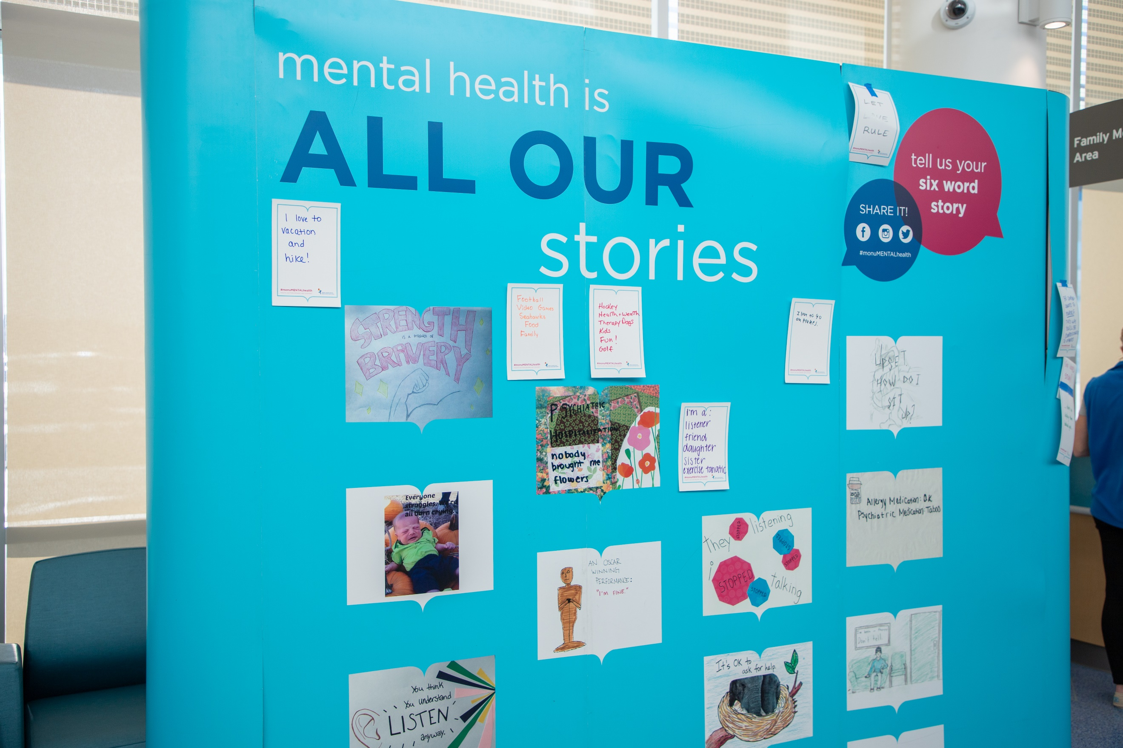

Registration
Register Here
This conference is being hosted in-person in the Conference Center at Children’s Hospital Colorado. A virtual option is also available for those unable to join us live at Children’s Hospital Colorado.
Register Early! A confirmation email will be sent with important details after registering.
Live registration will close at maximum capacity.
Select your location carefully, as onsite is limited.
Registration Fees: Live or Virtual
Community Professionals - $100.00
Children’s Hospital Colorado/Anschutz - $75.00
Verified Students* - $50.00
*Email student status verification to shaun.ayon@childrenscolorado.org within two days of registering.
Virtual attendees will be provided with course access link 1-3 days prior to the course.

Payment and Cancellation Policy
Online credit card payment is required at the time of registration. The registration fee is non-refundable, however if you are unable to attend, you may send a substitute (notification required). The Planning Committee reserves the right to modify the agenda or cancel this conference in the event of an unforeseen circumstance or of minimum acceptable registration is not attained by April 21, 2023, with a full refund to participants.

Continuing Education Credit
Medical: Children’s Hospital Colorado is accredited by the Accreditation Council for Continuing Medical Education to provide continuing medical education for physicians.
Children’s Hospital Colorado designates this Live activity for a maximum of 6 AMA PRA Category 1 Credit(s)™. Physicians should only claim credit commensurate with the extent of their participation in the activity.
Licensed Clinical Social Work: An application to award NASWCO Continuing Education Credits has been submitted. Determination of credit is pending.
Other: Upon completion of the evaluation, a general certificate of attendance is available to all other providers.

Parking
Conference visitor parking is located in Visitor Lot 10, located off Victor Street. Directions to Children’s Colorado – Aurora.
https://www.childrenscolorado.org/locations/anschutz-medical-campus-aurora/
Parking in patient structure is prohibited.

Further Information
For questions or to request arrangements to accommodate a disability, contact Shaun Ayon at 720-777-2700 or shaun.ayon@childrenscolorado.org at least 3 weeks prior to the conference.

SAVE THE DATE

May 3, 2024

