Neonatal and Pediatric Point-of-Care Ultrasound Course
April 12-13, 2025

Provided by Children’s Hospital Colorado
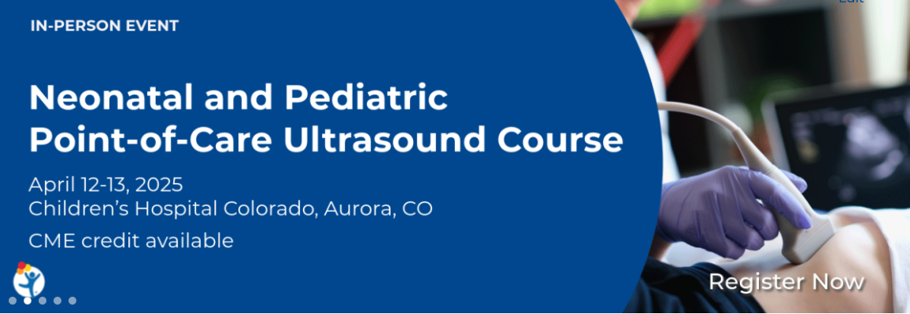
https://ce.childrenscolorado.org/content/neonatal-and-pediatric-point-care-ultrasound-course#group-tabs-node-course-default6

Needs Statement
Many neonatal and pediatric assessments continue to rely on indirect data and observation as the mainstay of decision-making. Point-of-care ultrasound (POCUS) has the potential to significantly improve care in neonatal and pediatric clinical practice by guiding invasive procedures and providing diagnostic data to supplement clinical observation.

Overview and Target Audience
This course is focused on neonatal and pediatric critical care medicine POCUS best practices. It is designed for neonatal, pediatric critical care, and emergency medicine physicians and advance practice providers with limited or basic knowledge of POCUS.

The course will be taught by multi-disciplinary pediatric POCUS experts and will have a low student-to-teacher ratio of 5-to-1. Through a combination of lectures and hands-on practical sessions using live pediatric models and simulation equipment, course attendees will learn ultrasound fundamentals (physics and principles of image generation) and scanning techniques pertinent to neonatal and pediatric practice. This will include: basic procedural guidance (peripheral vascular access, central line placement, lumbar puncture, etc.); bladder scanning; FAFF (focused assessment for free fluid); lung evaluation; basic cardiac function assessment; and advanced procedures (pericardiocentesis, peritoneal/pleural fluid drainage, etc.).

Educational Objectives
- Demonstrate core nonprocedural ultrasound skills (basic cardiac, FAFF, and lung exams) using live pediatric models
- Demonstrate core procedural ultrasound skills (intravenous line insertion and fluid drainage) using simulated skills stations
- Discuss appropriate indications and limitations of POCUS in neonatal and pediatric acute care settings

Continuing Education Credit
Medical:
Children’s Hospital Colorado is accredited by the Accreditation Council for Continuing Medical Education to provide continuing medical education for physicians and advance practice providers.

Children’s Hospital Colorado designates this Live activity for a maximum of 13.5 AMA PRA Category 1 Credit(s)™. Participants should only claim credit commensurate with the extent of their participation in the activity.

Other: A general certificate of attendance will be provided for all other healthcare providers.

Agenda
LIVE – In-Person

Saturday, April 12th
8:00 am | Registration and Breakfast | -
8:30 am | Welcome and Course Overview | Karena Lawrence
8:45 am | Physics and Fundamentals of Ultrasonography | Amanda Toney
9:15 am | Vascular Access and Basic Procedures | Ryan Good
9:45 am | Introduction to Abdomen (FAST/FAFF) | Daniel Lam
10:15 am | Lung Ultrasound: Anatomy and Pathology | Monti Sharma
10:45 am | Break | -
11:00 am | Hands-on Skills:  FAST/FAFF, Vascular Access, Lung | -
12:30 pm | Lunch | -
1:00 pm | Approach to Lumbar Punctures (LPs) | Wil Corder
1:20 pm | Umbilical Venous Cannulation in Neonates | Karena Lawrence
1:45 pm | Cardiac Basics | Sam Lam
2:15 pm | Break | -
2:30 pm | Hands-on Skills:  Subcostal/IVC, Apical, and Parasternal Views | -
4:30 pm | Questions/Adjourn | -

Sunday, April 13th
8:00 am | Breakfast | -
8:30 am | Day 1 Review (15 minutes) | Karena Lawrence
8:45 am | LV and RV Systolic Function | Thomas Conlon
9:15 am | Shock and Hypotension | Francis Beauchamp
9:45 am | Diaphragm | Christie Glau
10:15 am | Airway, Endotracheal Tube Position, Vocal Cords | Sarah Gitomer
10:45 am | Break | -
11:00 am | Hands-on Skills:  Shock/Volume, Systolic Function, Airway/Diaphragm | -
12:30 pm | Lunch | -
1:00pm | Basics of Head US | Wil Corder
1:20 pm | Approach to POCUS During Resuscitation | Julia Brant
1:45 pm | Translating Training to Clinical Practice | Panel Session
2:15 pm | Break | -
2:30 pm | Hands-on Review:  Abdomen, Thorax, Cardiac Cases/Review | -
4:00 pm | Adjourn | -

Course Directors:
Karena G. Lawrence, MD, MS
Director, Neonatal POCUS Program
Associate Professor of Pediatrics
Section of Neonatology
Children’s Hospital Colorado
University of Colorado School of Medicine

Ryan Good, MD
Director, Pediatric Critical Care POCUS Program
Associate Professor of Pediatrics
Section of Pediatric Critical Care Medicine
Children’s Hospital Colorado
University of Colorado School of Medicine

Julia Brant, MD
Co-Director, Pediatric Emergency POCUS Program
Assistant Professor of Pediatrics
Section of Pediatric Emergency Medicine
Children’s Hospital Colorado
University of Colorado School of Medicine

Course Faculty:
Aly Arenstein, DNP, NNP-BC
APP Lead, Neonatal POCUS Program
Section of Neonatology
Children’s Hospital Colorado
University of Colorado School of Medicine

Francis-Olivier Beauchamp, MD
Division of Pediatric Critical Care
Children’s Hospital of Philadelphia
Perelman School of Medicine at the University of Pennsylvania

Thomas Conlon, MD
Director, Pediatric Critical Care Ultrasound
Assistant Professor of Anesthesiology and Critical Care Medicine
Children’s Hospital of Philadelphia
Perelman School of Medicine at the University of Pennsylvania

Michael Cookson, MD
Assistant Professor of Pediatrics
Section of Neonatology
Children’s Hospital Colorado
University of Colorado School of Medicine

Wil Corder, MD
Assistant Professor of Clinical Pediatrics
Division of Neonatology
Children’s Hospital of Philadelphia
Perelman School of Medicine at the University of Pennsylvania

Nicolle Dyess, MD, MEd
Assistant Professor of Pediatrics
Section of Neonatology
Children’s Hospital Colorado
University of Colorado School of Medicine

Sarah Gitomer, MD
Program Lead, Microtia/Atresia Clinic
Assistant Professor of Pediatrics
Department of Otolaryngology—Head and Neck Surgery
Children’s Hospital Colorado
University of Colorado School of Medicine

Christie Glau, MD
Assistant Professor of Anesthesiology and Critical Care Medicine
Division of Pediatric Critical Care
Children’s Hospital of Philadelphia
Perelman School of Medicine at the University of Pennsylvania

John Kim, MD
Associate Medical Director, Cardiac Intensive Care Unit
Director, Cardiac Antithrombosis Management Program
Associate Professor of Pediatrics
Pediatric Cardiology and Cardiac Critical Care
Children’s Hospital Colorado
University of Colorado School of Medicine

Sarah Kohn, MD
Neonatal-Perinatal Medicine Fellow
Section of Neonatology
Children’s Hospital Colorado
University of Colorado School of Medicine

Daniel Lam, MD
Assistant Professor of Pediatrics
Division of Pediatric Emergency Medicine
UCSF Benioff Children’s Hospital
University of California San Francisco

Samuel Lam, MD, MPH, RDMS
Co-Director, Pediatric Emergency POCUS Program
Professor of Pediatrics
Section of Pediatric Emergency Medicine
Children’s Hospital Colorado
University of Colorado School of Medicine

Monti Sharma, MD
Director, Neonatal POCUS Program
Assistant Professor of Pediatrics
Divisions of Neonatology and Pulmonology
Children’s Nebraska
University of Nebraska Medical Center

Amanda Toney, MD
Associate Professor of Pediatrics
Director of Pediatric Emergency Ultrasound
Division of Emergency Medicine
Denver Health Medical Center
University of Colorado School of Medicine

Juliana Wilson DO, MPH, AEMUS-FPD
Director of Ultrasound Curriculum School of Medicine
Associate Professor of Emergency Medicine
Department of Emergency Medicine
University of Colorado School of Medicine
Registration

Register online: https://ce.childrenscolorado.org

Register online by March 29, 2025

Registration Fee:
External physicians $1,100.00
APPs/Fellows/CHCO-providers $600.00

This fee includes breakfast, refreshments, lunch, parking, and course materials.

Cancellation Policy:
The Planning Committee reserves the right to alter the agenda or cancel the conference in the event of an unforeseen circumstance, or if the minimum registration is not attained by March 29, 2025.

Online refunds may be processed through March 29, 2025 minus a $150 cancellation fee. After this date no refunds will be granted for non-attendance. Substitutions are permitted prior to the conference without any penalty.

Location and Parking:
The conference will be held at Children’s Hospital Colorado, Aurora. 13123 East 16th Avenue, Aurora, CO 80045. Conference participants may park in the Visitor Parking structure.

Children’s Colorado and University of Colorado Hospital employees must park in their designated area.

Further Information:
If you have questions or to request arrangements to accommodate a disability, please contact Shaun Ayon, shaun.ayon@childrenscolorado.org at least 3 weeks prior to the conference.

