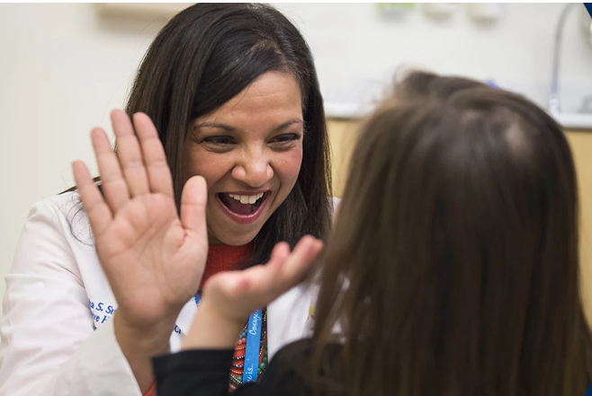

developmental pediatrics and children’s hospital colorado presents:
2nd Annual Autism Extravaganza
In Collaboration with the ARC of the Central Mountains

Date: April 16, 2026

Developmental Pediatrics at Children’s Hospital Colorado is looking to expand their already active partnerships with Primary Care Providers to support autistic youth and their families across the state of Colorado. We are excited to offer our 2nd Annual Autism Extravaganza in Glenwood Springs on April 16, 2026.

Join us for this interactive, full-day workshop to build knowledge and skills and strengthen our community partnerships.

Location:
Morgridge Commons Conference Center
815 Cooper Ave 2nd Floor Glenwood Springs, CO 81601


Autism Extravaganza

Objective Overview
- Describe the diagnostic criteria for pediatric autism as outlined in DSM 5
- Describe diagnostic criteria to be assessed during structured interviews and observations
- Identify common resource pathways for different presentations of autism
- Apply individualized therapeutic recommendations and medical management of co-occurring conditions

Agenda

Thursday, April 16, 2026
This year we will be featuring two distinct tracks full of new educational content! See below for a sample schedule of the day’s offerings:
8:00: BREAKFAST
8:15-9:15: What is Autism; An Introduction to Neurodiversity
9:30-10:15: Early Intervention OR Screening for Autism in Primary Care
10:15-11:00 Autism and Co-Occurring Mental Health Conditions OR Conducting an Autism Interview Part 1
11:15-12: Autism and Co-Occurring Medical Conditions OR Conducting an Autism Interview Part 2
12-12:45: Behavior Management/Irritability OR Providing and Documenting Diagnosis
LUNCH
1:30-2:30 Cultural Considerations
2:30-3:30 Resources and Next Steps
3:30-4:15: Stories of Lived Experience
Closing Remarks
5:00: Networking Happy Hour! Location TBD

Registration
Community Physicians – MD/DO - $150.00
All Other Providers - $0.00
Marked attendance and completion of the online evaluation is required for verified participation.
Cancellation Policy: Online refunds may be processed through April 2, 2026 minus a $25 cancellation fee. After this date no refunds will be granted for non-attendance.
Substitutions are permitted prior to the conference without any penalty and prior notification.
The Planning Committee reserves the right to modify the agenda or cancel this conference in the event of an unforeseen circumstance.


Continuing Education Credit
Children’s Hospital Colorado is accredited by the Accreditation Council for Continuing Medical Education to provide continuing medical education for physicians.
Children’s Hospital Colorado designates this live activity for a maximum of 6.75 AMA PRA Category 1 Credit(s)™. Physicians should only claim credit commensurate with the extent of their participation in the activity.
A general certificate of attendance will be provided with marked attendance and completion of the online evaluation.

Parking
Please allow extra time for parking and navigating to the Conference Center.
Paid parking is available at the 9th and Cooper Parking Garage - 91-923 Cooper Ave, Glenwood Springs, CO 81601

Presenting Faculty

Abigail Angulo, MD, MPH
Medical Director, Associate Professor
Developmental Pediatrics, Children’s Hospital Colorado

Liz Coan, PsyD
Director, PCN Autism Program, Associate Professor
Developmental Pediatrics, Children’s Hospital Colorado

Maritza Cobian, PsyD
Assistant Professor
Developmental Pediatrics, Children’s Hospital Colorado

Joanna Dreyer, PharmD, BCPPS
Clinical Pharmacist, Instructor
Developmental Pediatrics, Children’s Hospital Colorado

Sandra Friedman, MD, MPH
Director, JFK Partners, Professor
Developmental Pediatrics, Children’s Hospital Colorado

Elizabeth Griffith, PhD
Associate Professor
Developmental Pediatrics, Children’s Hospital Colorado

Lisa Hayutin, PhD
Associate Professor
Developmental Pediatrics, Children’s Hospital Colorado

Sara Mattie, LCSW
Instructor
Developmental Pediatrics, Children’s Hospital Colorado

Pat Romani, PhD, BCBA-D
Associate Professor
Developmental Pediatrics, Children’s Hospital Colorado

Ann Reynolds, MD
Section Head, Professor
Developmental Pediatrics, Children’s Hospital Colorado

Rebecca Wilson, MD
Chair of Psychology, Clinical Professor
Developmental Pediatrics, Children’s Hospital Colorado

