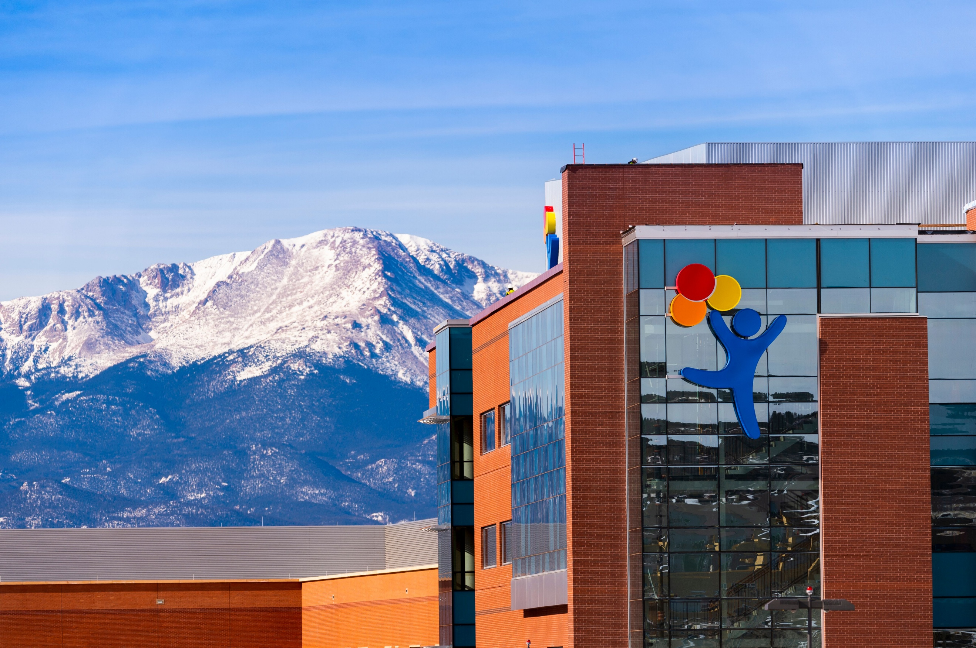

developmental pediatrics and children’s hospital colorado presents:
Southern Colorado
Autism Conference

Date: May 14, 2026

Developmental Pediatrics at Children’s Hospital Colorado is looking to expand their already active partnerships with Primary Care Providers to support autistic youth and their families across the state of Colorado.

We are excited to share the Inaugural Annual Autism Conference.

Join us for this interactive, full-day workshop to build knowledge and skills and strengthen our community partnerships.

Location:
The Pinery at the Hill
775 W. Bijou St, Colorado Springs, CO 80905

Southern Colorado Autism Extravaganza

Objective Overview
- Describe the diagnostic criteria for pediatric autism as outlined in DSM 5
- Describe diagnostic criteria to be assessed during structured interviews and observations
- Identify common resource pathways for different presentations of autism
- Apply individualized therapeutic recommendations and medical management of co-occurring conditions

Agenda

Thursday, May 14, 2026
This year we will be featuring two distinct tracks full of new educational content! See below for a sample schedule of the day’s offerings:
8:00: Continental Breakfast - Welcome
8:15-9:15 - What is Autism; An Introduction to Neurodiversity (Drs. Angulo, Coan, Hayutin)
9:30-10:15 - Early Intervention (Drs. Deer, Louderman) OR Conducting an Autism Interview Part 1 (Drs. Angulo, Coan)
10:15-11:00 - Autism and Co-Occurring Mental Health Conditions (Drs. Hayutin, Losh, Varnet) OR Conducting an Autism Interview Part 2 (Drs. Angulo, Wilson)
11:15-12 - Autism and Co-Occurring Medical Conditions (Dr. Dreyer, NP Parrillo) OR Providing and Documenting Diagnosis (Drs. Angulo, Coan)
12:00 p.m Lunch (provided)
12:45-1:30 - Behavior Management/Irritability (Drs. Coan, Dreyer)
1:30-2:30 – Working with Military Families (Sarah McSwegin, Matt Ecklund, Gemma Smith)
2:30-3:30 - Resources and Next Steps (Sarah McSwegin, Matt Ecklund, Gemma Smith)
3:30-4:15 - Stories of Lived Experience (Mediated by Dr. Coan)
Closing Remarks
5:00: Networking Happy Hour – Colorado Mountain Brewery 600 21st Street, Suite 180, Colorado Springs, CO 80904

Registration
*Community Physicians – with CME – MD/DO - $150.00
Community Physicians – NO CME – MD/DO - $0.00 All Other Providers – with CME attendance - $0.00
* Excludes Children’s Colorado, CU-SOM Anschutz Affiliate
Children’s Hospital Colorado sets registration fees in accordance with federal guidelines to ensure compliance with regulations governing financial relationships in healthcare.
Marked attendance and completion of the online evaluation is required for verified participation.
Cancellation Policy: Online refunds may be processed through April 30. After this date no refunds will be granted for non-attendance.
Substitutions are permitted prior to the conference without any penalty and prior notification.
The Planning Committee reserves the right to modify the agenda or cancel this conference in the event of an unforeseen circumstance.
Register Here:


Continuing Education Credit
Children’s Hospital Colorado is accredited by the Accreditation Council for Continuing Medical Education to provide continuing medical education for physicians.
Children’s Hospital Colorado designates this live activity for a maximum of 6.75 AMA PRA Category 1 Credit(s)™. Physicians should only claim credit commensurate with the extent of their participation in the activity.
A general certificate of attendance will be provided with marked attendance and completion of the online evaluation.

Presenting Faculty
Abigail Angulo, MD, MPH
Medical Director, Associate Professor
Developmental Pediatrics, Children’s Hospital Colorado

Liz Coan, PsyD
Director, PCN Autism Program, Associate Professor
Developmental Pediatrics, Children’s Hospital Colorado

Kate Deer, PsyD
Assistant Professor
Developmental Pediatrics, Children’s Hospital Colorado

Joanna Dreyer, PharmD, BCPPS
Clinical Pharmacist, Instructor
Developmental Pediatrics, Children’s Hospital Colorado

Matt Ecklund
Family Navigator
Developmental Pediatrics, Children’s Hospital Colorado

Ainsely Losh, PhD
Assistant Professor
Developmental Pediatrics, Children’s Hospital Colorado

Megan Louderman, PhD
Assistant Professor
Developmental Pediatrics, Children’s Hospital Colorado

Lisa Hayutin, PhD
Associate Professor
Developmental Pediatrics, Children’s Hospital Colorado

Sarah McSwegin, LCSW
Instructor
Developmental Pediatrics, Children’s Hospital Colorado

Elaina Parrillo, PhD, DNP, CPNP-PC
Assistant Professor
Developmental Pediatrics, Children’s Hospital Colorado

Ann Reynolds, MD
Section Head, Professor
Developmental Pediatrics, Children’s Hospital Colorado

Gemma Smith, MSW
Instructor
Developmental Pediatrics, Children’s Hospital Colorado

Marie Varnet, MD
Assistant Professor
Developmental Pediatrics and Pediatric Neurology, Children’s Hospital Colorado

Acknowledgement

Thank You for the generous donation:

Great Clips

