

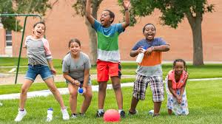



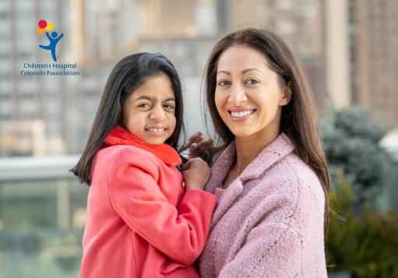
The Rosenberry conference
Working with Immigrant Youth and Families: Culture, Community, and Context
May 15, 2026
Children’s Hospital Colorado
Anschutz Medical Campus

Provided by
Children’s Hospital Colorado, Pediatric Mental Health Institute

The Rosenberry Conference

Course Overview and Target Audience
Immigrant youth and families may present with unique service needs and unique vulnerabilities that require more cultural and contextual-specific strategies. Integrating this understanding of the community’s unique needs into care, in the context of social and structural determinants of health, facilitates service delivery that can improve their behavioral health outcomes. Yet, immigrant youth and families may face various barriers to accessing and engaging in needed healthcare.
Working with Immigrant Youth and Families: Culture, Community, and Context seeks to empower behavioral health organizations and providers to promote behavioral health equity through skills to address social and structural determinants of health. Simultaneously, it will equip behavioral health professionals with skills and strategies to enhance their clinical practice, community collaboration, and advocacy, fostering a community-centered approach to improve health outcomes. This multi-layered approach supports community resilience and aligns with a broader vision for a more equitable behavioral health care system for the immigrant community.

Learning Objectives
- Outline social and structural determinants of health to promote health equity for immigrant youth and families
- Describe the importance of cultural values and strengths in providing culturally responsive care
- Apply principles of culturally responsive care to service delivery with immigrant communities
- Outline strategies for building community partnerships to improve access and provision of behavioral health care for immigrant youth and families
- Identify steps and strategies for behavioral health professionals to integrate knowledge of social and structural determinants of health across domains of professional practice
- Explain why advocacy is critical to address the social and structural context of care for the immigrant community
- Outline macro and micro level interventions that can sustain positive change

Agenda

Friday, May 15, 2026

7:30a Check-In – Breakfast (provided)

8:00 Welcome
Morgan Spellman, PsyD
Ron-Li Liaw, MD

8:15 Promoting Health Equity: Culturally Responsive Care for Immigrant Youth and Families
Marilyn L Sampilo, PhD, MPH

9:45 Break

10:00 Breaking Barriers and Bridging Gaps: Building Community Networks and Partnerships to Support Immigrant Youth and Families
Marilyn L Sampilo, PhD, MPH

11:45 Lunch (provided)

12:30 Community Expert Panel
Elisa Aucancela, MA
Veronica Laveta, LCSW
Daniel Savin, MD,
Nai Chieh (Geri) Tien, Ph.D, LP, LMFT
Erin Twiehaus, LCSW
Talie Watzman, LCSW

2:00 Considering Care in Context: Advocacy as a Professional Priority to Support Immigrant Mental Health
Marilyn L Sampilo, PhD, MPH

3:30 Closing Comments

3:45 Evaluation and Adjourn

Guest Faculty
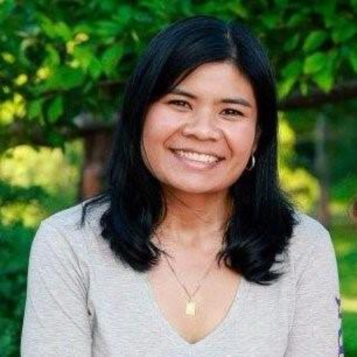
Marilyn L. Sampilo, PhD, MPH is a licensed clinical psychologist specializing in integrated behavioral health and health equity for underserved communities. She currently works as a pediatric psychologist at an academic health center in the Midwest. She received her doctoral degree (PhD) in clinical child psychology, with specialization in pediatric psychology, and a Master of Public Health, with specialization in social and behavioral aspects of public health, from the University of Kansas. Dr. Sampilo’s pedigree in education and training have allowed her to develop extensive experience in prevention, health promotion and intervention for diverse populations. Dr. Sampilo is particularly passionate about addressing structural and systemic drivers of behavioral health inequity in partnership with communities. Nationally, she provides consultation, training and professional development in the areas of health equity and affirming, culturally responsive health care, with over 100 invited presentations and trainings in these areas. She serves on several national committees and work groups focused on promoting culturally and linguistically appropriate health service delivery and has held various leadership roles in the areas of health equity and cultural competency at several organizations over the last decade. Dr. Sampilo has received several local and national awards for her work in service to communities including the 2024 APA Committee on Children, Youth, and Families Early-career Award for Outstanding Contributions to Benefit Children, Youth, and Families, the 2023 Su Casa Hispanic Center Latino Leadership Award, the 2022 Roger Harrison IDEAS (Inclusion, Diversity, and Excellence in Advocacy and Social Justice) Award, and the 2022 SPP Award for Distinguished Contributions to Diversity in Pediatric Psychology.

Community Expert Panel

Aurora Mental Health & Recovery: Cultural Development and Wellness Center
- Asian Pacific Clinic: Nai Chieh (Geri) Tien, PhD, LP, LMFT
- Refugee & Immigrant Clinic: Veronica Laveta, LCSW

Rocky Mountain Welcome Center: Erin Twiehaus, LCSW

Jewish Family Services: Talie Watzman, LCSW

El Grupo Vida: Elisa Aucancela, MA

CU Immigrant & Refugee Mental Health Clinic: Daniel Savin, MD

Acknowledgement
The Rosenberry Conference is an annual event held in honor of Walter S. Rosenberry III, a former board member and benefactor of Children’s Hospital Colorado. Mr. Rosenberry’s support of Children’s Hospital Colorado and Department of Psychiatry and Behavioral Sciences provides us with an opportunity to recognize and honor those individuals who have made significant contributions to the field of psychology and behavioral sciences.
Registration
Register Here
This conference is being hosted in-person at our Conference Center at Children’s Hospital Colorado. A virtual option is also available for those unable to join us live at Children’s Hospital Colorado.
Register Early! A confirmation email will be sent with important details after registering.
Live registration will close at maximum capacity, please select in-person or virtual attendance at check out.

Registration Fees: In-person or Virtual
Community Professionals - $100.00
Children’s Hospital Colorado/Anschutz - $75.00
Verified Students* - $50.00
*Please email student status verification to shaun.ayon@childrenscolorado.org
Virtual attendees will be provided with a course access link 1-2 days prior to the course.
Payment and Cancellation Policy
Online payment is required at the time of registration. The registration fee is non-refundable, however if you are unable to attend, you may send a substitute (notification required). The Planning Committee reserves the right to modify the agenda or cancel this conference in the event of an unforeseen circumstance or of minimum acceptable registration is not attained by May 1, 2026, with a full refund to participants.

Continuing Education Credit

Medical: Children’s Hospital Colorado is accredited by the Accreditation Council for Continuing Medical Education to provide continuing medical education for physicians.
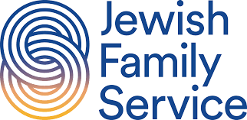
Children’s Hospital Colorado designates this Live activity for a maximum of 6.5 AMA PRA Category 1 Credit(s)™. Physicians should only claim credit commensurate with the extent of their participation in the activity.
Licensed Clinical Social Work: An application to award NASWCO Continuing Education Credits has been submitted. NASWCO CE credit is approved.
Other: General certificate of attendance provided with completion of the evaluation.

Parking
Free - Conference Visitor Lot 10. Enter from Victor Street only. Directions to Children’s CO – Aurora. https://www.childrenscolorado.org/locations/anschutz-medical-campus-aurora/
Further Information
For questions or to request arrangements to accommodate a disability, contact Shaun Ayon at 720-777-2700 or shaun.ayon@childrenscolorado.org at least 3 weeks prior to the conference.
We look forward to seeing you next year!


Save the Date – May 7, 2027