CME Credits for Quarterly Upgrade Training for Providers

Children’s Hospital Colorado - Clinical Application Services

Q4 2026 Epic Upgrade & Aligned Projects
Release Date: October 26, 2026
Expiration Date: January 31, 2027

Estimated time for completion = 1 hour

Objectives:
- Enhance Provider Proficiency in Epic System Updates
Identify and apply key functionality changes introduced in the quarterly Epic upgrade to improve clinical efficiency and accuracy in documentation and order entry.

- Promote Safe and Efficient Patient Care
Recognize and implement updated workflows and safety enhancements within the Epic system that support timely, evidence-based decision-making and reduce the risk of errors.

- Support Regulatory and Institutional Compliance
Demonstrate an understanding of system changes that support institutional policies, billing compliance, and clinical quality metrics, ensuring alignment with both internal and external regulatory standards.

Target Audience and Overview: Physicians, Advanced Practice, and other health professionals involved in the care and management of pediatric patients.

CME Credit:
Children’s Hospital Colorado is accredited by the Accreditation Council for Continuing Medical Education to provide continuing medical education for physicians.

Children’s Hospital Colorado designates this Enduring Material for a maximum of 1 AMA PRA Category 1 Credit(s) ™. Physicians should only claim credit commensurate with the extent of their participation in the activity.

Disclosures:
All planners, faculty, and others in control of content (either individually or as a group) have no relevant financial relationships with ineligible companies.
Peer Review
Dr. Gwen Kerby
Professor, Pediatrics-Pulmonary Medicine
Medical Director, Pulmonary Diagnostics, Children's Hospital Colorado
Chief Medical Information Officer, Children's Hospital Colorado
Breathing Institute, Children's Hospital Colorado

Dr. Carleen Schneiter
Physician, Critical Care
Provider Informaticist
Children's Hospital Colorado

Registration – Claim your CME credits for this course:

- Complete the assigned Epic Upgrade module in Cornerstone by January 31st, 2027.

- Finish the attestation at the end of the Cornerstone training.

- Navigate to the CE Website with this LINK to quickly claim your Q4 2026 credit.

- Select the login hyperlink from the CE site.

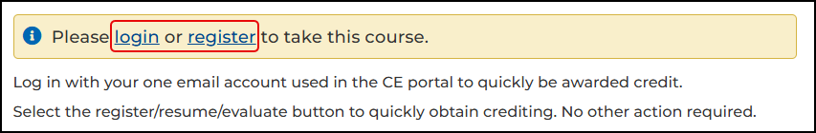

- Log in to the Continuing Education Portal with your usual Single Sign On or use Guest Sign In if you’re using a University email. Only create a new account if you truly need to.

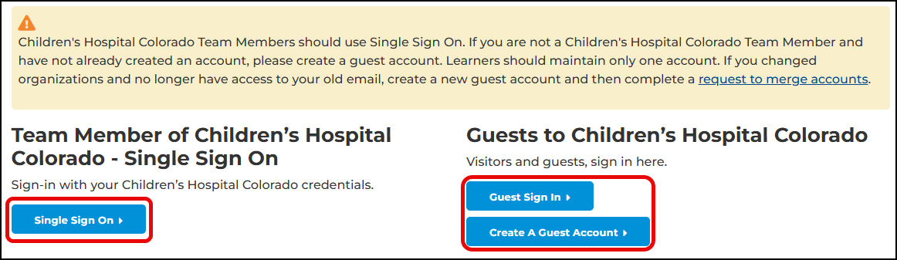
- Select the Register/Resume/Evaluate button to quickly obtain crediting. No other action is required.


The provider-facing topics included in this quarter’s module are:

- MyChart Problem List Sharing
- The End of Life Project
- AI Generated Inpatient Insight Patient Story w/Cards
- Paperless AVS
- Outpatient Medication Review and Reconciliation Changes

View our complete course calendar and other educational offerings here: https://ce.childrenscolorado.org

CE Support: Continuing Education at ce@childrenscolorado.org or
by calling the CE Team at (720) 777-5004.

